|  |
| --- |
| Principles and Applications of Digital Image Processing |

【Fall, 2019】

Homework 6

**Part 1: (30%) Geometric Transformation**

Design a computer program for geometric transformation of an image. Try to find the optimal geometric transformation to obtain the warped images shown below. Describe your approach as clearly as possible and show the resulting images. You may also challenge yourself by designing an interactive interface for more flexible geometric transformation.

|  |  |
| --- | --- |
| 描述: D:\課程資料\C1-影像處理原理與應用\影像處理原理與應用影像\IP_dog.bmp | 描述: D:\課程資料\C1-影像處理原理與應用\影像處理原理與應用影像\IP_dog1.bmp |
| Original Image | Trapezoidal Transformation |
| 描述: D:\課程資料\C1-影像處理原理與應用\影像處理原理與應用影像\IP_dog3.bmp | 描述: D:\課程資料\C1-影像處理原理與應用\影像處理原理與應用影像\IP_dog2.bmp |
| Wavy Transformation | Circular Transformation |

**Part 2: (30%) Image Fusion Using Wavelet Transform**

The algorithm of image fusion using DWT is described in the following steps:

1. The size of images to be fused needs to be the same size and the resolution needs to be of power of two.

2. The two dimensional Discrete Wavelet Transform (DWT) should be applied to the resized images.

3. Fusion rule: The most used image fusion rule using wavelet transform is maximum selection, by comparing the DWT coefficients of the two (or more) images and select the maximum. While the lowpass subband is an approximation of the input image, the three detail subbands convey information about the detail parts in horizontal, vertical and diagonal directions. Different merging procedures will be applied to approximation and detail subbands. Lowpass subband will be merged using simple averaging operations since they both contain approximations of the source images, and the maximum selection rule is applied to detail subbands, as shown in the following figure.

4. After selecting the fused low frequency and high frequency bands, fused image is reconstructed using the inverse DWT from on the subbands determined in step 3.

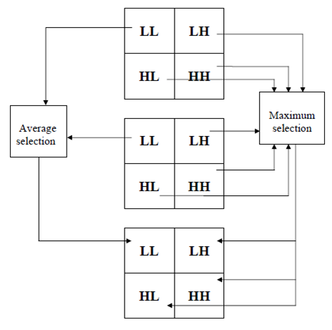

Implement an image fusion program applying the DWT method as described above.

1. Test your program with the image sets provided in this homework and image sets you wish to test.
2. Quantitatively and qualitatively compare and discuss the effect of the image fusion results using different scales of decomposition.

**Part 3: (40%) Hough Transform**

Apply Hough transform method described in 10.2 of our textbook to find the sides of the two rectangular papers in the image RECTS.BMP (available from the CEIBA course website). Determine the areas and perimeters of the two rectangular papers assuming the scale factor is 0.5 mm/pixel in both horizontal and vertical directions.

Try your Hough transform program for other images containing multiple lines. What are the major factors affecting the performance of your Hough transform program. Discuss and report your results in details.

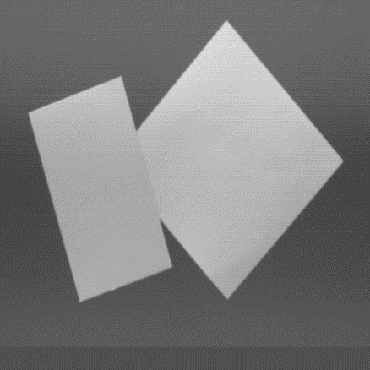

**Notes:**

1. Please submit your programs and report to the CEIBA course website before **Dec. 4** **(2:20PM).**
2. Late submission will have a penalty of 10% discount per day of your homework total score toward a maximum of 50% discount. No late submission over five days will be accepted.